‘Tuck Everlasting’ Is A Childhood Classic That Stands The Test Of Time

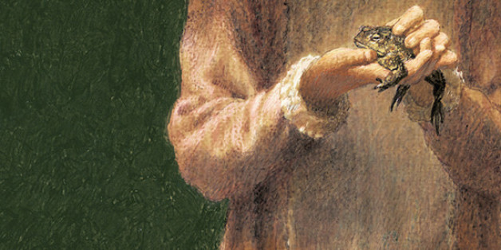

MACMILLAN

*The following is an excerpt from*[*the 40th anniversary edition of Natalie Babbitt’s* Tuck Everlasting](http://www.amazon.com/Tuck-Everlasting-Natalie-Babbitt/dp/1250059291?tag=thehuffingtop-20)*, for which* Wicked *author Gregory Maguire wrote the introduction. Below, Maguire cites the Young Adult novel’s merits as a work with rich and timeless themes.*

Time, like story, moves only forward.

Once you open a book and read the first line — like my six­-word sentence above — you can never un-read it. You might forget it till you see it again, but you can never return to the state of total unknowing.

The same holds true for storytelling.

Now, I don’t know about you, but I am the sort who tries very hard not to read the front flap of a dust jacket. Those beckoning paragraphs often give away the plot. Consequently, I avoid reviews, blurbs, jacket copy, and forewords whenever I can. I prefer to explore a text on my own, to discover its secrets for myself. No spoilers.

If you’ve never read *Tuck Everlasting* before, and you feel as I do, why not let the author of this book, Natalie Babbitt, share this story at her own pace and discretion? I remember what it means to approach this book for the first time, having no notion what lies ahead.

So I have an idea. Pause here. Jump ahead and read *Tuck Everlasting*. This story shoots like an arrow off a quivering bow. When you’ve finished, come back to the asterisks below and finish the foreword.

But linger in the story as long as you like. I’m in no hurry. I have all the time in the world. You’ll be back at these asterisks before you know it.

While a reader can never go back and encounter a book again for the first time, one of the many miracles in storytelling is this: A story has an infinite number of opportunities to begin.

Think of it this way. Imagine you take this very volume that you have in your hands to your grandfather, who has lost his reading glasses. You say to him “I just finished this fantastic book and I want to share it with you. Listen.”

You open to the first page (again). You read the prologue with its image of time like a never-ending circle. Time like a revolving Ferris wheel supplied with a year’s worth of months, a wheel that never alters the order of progression. (April must follow March.) Nor the rate of progress. (The Fourth of July happens precisely every 365 days. Except in a leap year — every rule has its exception.)

What an unforgettable image that is, by the way. “The first week of August hangs at the very top of summer the top of the live-long year...” I’ve remembered it for nearly forty years already. I’ve gone around on time’s Ferris wheel nearly forty times since I first read this prologue. I also love that phrase, “the live-long year.”

Then you turn to the first chapter, about “the road that led to Treegap,” and then the second chapter, about Mae Tuck setting out to meet her sons, Miles and Jesse, who “had... looked exactly the same for eighty-seven years.”

Weird and wonderful as this is, you press on. Chapter three. Winnie Foster talks to a toad in the road about wanting to be alone for a while, wanting to be unsupervised.

Here’s the funny thing. You are encountering Winnie again. You know what she is going to find, and face, and fume about, and figure out. But for your grandfather, listening intently, and for Winnie, she is beginning her adventure as if it has never happened.

It’s almost as if, in a story, time has two different talents: the talent to proceed inevitably, like an arrow across a meadow aiming toward a target, and a talent to begin again, like that Ferris wheel rolling endlessly through its circuit.

This is true of all stories. Jill Paton Walsh, a writer friend of mine, once wrote that you need only open Act One of *Hamlet* to find the ghost of Hamlet’s father haunting the ramparts of Elsinore, and all the bloody sorrow of that drama begins again. Every time you read “In a hole in a ground there lived a Hobbit,” you realize that Bilbo Baggins’s departure from the Shire and his eventual encounter with Smaug is all ahead of him—and you. The endings of stories are intact, waiting for you to get there. For every “once upon a time” there is a “happily ever after.”

Well. Almost. This story may be an exception to that rule. For while this story has an absolute beginning, a “once upon a time,” *Tuck Everlasting* — alone of all the stories I have ever read in my entire life — has no absolute end.

When I was instructing young people who wanted to become English teachers, I found that many of them didn’t know the difference between plot and theme. I tried to help them. A plot, I said, is what happens. It involves the names of characters and the actions they take. Charlotte spins a web with words in it to save Wilbur the pig from becoming bacon. That’s a plot. It happens in time and in sequence: first threat, then Charlotte’s solution, then rescue. In that order. A theme, I said, tells why the author wrote the book. A theme is the ambitious idea upon which an author stands when aiming the arrow of plot. A theme must be explained without using the names of characters or the description of events. In *Charlotte’s Web*, one theme might be: True friendship is worth sacrifice. In *The Hobbit*, one theme might be: Even the lowly may do great deeds. In *Hamlet*, one theme might be: Self-knowledge is essential to strive for but may be impossible to gain. In *Tuck Everlasting* — this book belongs among those other great works of literature — one theme might be: Every choice we make has a reward and a cost.

Books can have more than one theme. That’s one of the reasons to reread them. That is why I can reread Tuck Everlasting over and over, even though when I meet Winnie Foster again standing in her front yard, I know exactly what she will do later in the book. What I don’t know is what it will mean to me now. For I grow older, year by year. Life and joy, sorrow and understanding, they all wash against me, changing me day by day, year by year. When I return to the same place on time’s Ferris wheel that I remember from the year before, the place may seem the same but I have changed. I have to look again, to see what the author’s views might suggest to me, what they mean now.

Okay. Maybe you’re one of those people, like Winnie, who doesn’t always follow the rules. Even if you’ve never read *Tuck Everlasting* before, you may not have taken my advice. You may have ripped ahead this far into my foreword before slipping into the novel itself. If so, you’ll be relieved to learn that I’ve worked hard not to give the plot away. I’ve hinted about a lot of things, but I’ve done so slyly. After you do finish reading the novel, come back and reread this foreword again. The words will be familiar to you, but they’ll mean something different because you’ll be a different person. You’ll be a person who has now read *Tuck Everlasting*.